Civil war in Somalia

UNSC Resolution: | 746
Date of adoption: | 17-Mar-1992
Operative paragraph: | 10
Demand number: | 746,1011

Sarah-Myriam Martin-Brûlé

Wording of demand

cooperate fully with the Secretary-General in the implementation of the present resolution

List of addressees of the demand

Government of Somalia, United Somali Congress Faction

Short-term compliance

Description of the addressee(s)’ conduct

The team visited Somalia from 23 March to 1 April. Following discussions with the team, Interim President Ali Mahdi and General Aidid signed on 28 and 27 March 1992, respectively, Letters of Agreement on the mechanisms for monitoring the cease-fire and on arrangements for equitable and effective distribution of humanitarian assistance.

United Nations Operation in Somalia II
http://popp.gmu.edu/peace/unosom_ii.html

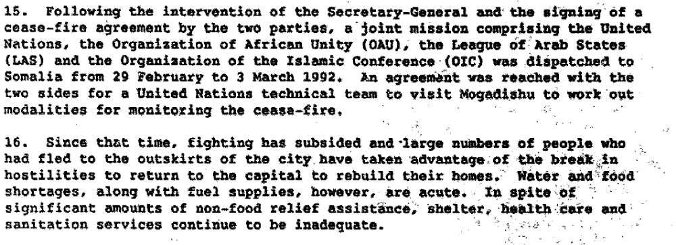

Report of the Secretary General on the Situation in Somalia, 21 April 1992 S/23829/.

Assessment

Short-term compliance
No or marginal compliance (1) | X Medium low compliance (2) | Medium high compliance (3) | Full or almost full compliance (4)

Considerations underlying the assessment
They agreed on the resolution yet failed to implement it.

Medium-term compliance

Description of the addressee(s)’ conduct

“10. The visit of Under-Secretary-General Jonah to the area was followed by a series of Security Council resolutions on Somalia as well as the appointment of a special representative of the Secretary-General, fist Mr. Mohammed Sahnoun of Algeria, on 1 May 1992, and then Mr. Ismat Kittani of Iraq, on 3 November 1992.

11. Apart from the efforts of the Special Representatives in Somalia itself, several meetings on humanitarian assistance to Somalia were convened by the Secretary-General at which representatives of the donor countries, other Governments, Somali political and community leaders, regional and subregional non-governmental organizations, United Nations agencies and international NGOs were present

12. Despite the efforts of the Secretary-General, the situation continued to deteriorate as Somalia remained without a central government and Mogadishu was divided by rival militia. Not only did the extensive physical destruction of the country severely constrain the delivery of humanitarian supplies, but several of the Somali de facto authorities refused to agree to the deployment of United Nations troops to secure delivery of aid in areas of the greatest need.”

Advisery Services in the Field of Human Rights, Item 19 of the provisional agenda 9 February 1994, 1994/77/Add. 1
Report by the independent expert, Mr. Fanuel Jariretundu Kozonguizi, on the conditions in Somalia, prepared in accordance with paragraph 6 of Commission on Human Rights resolution 1993/86, Addendum
http://rsq.oxfordjournals.org/cgi/reprint/13/2-3/159.pdf

Assessment

Medium-term compliance
No or marginal compliance (1) | X Medium low compliance (2) | Medium high compliance (3) | Full or almost full compliance (4)

Considerations underlying the assessment

Each party would agree to meet with the Secretary-General Representative but would fail to comply with the agreements.

Depth of demand

Assessment

Level of depth of demand
X Low depth of demand (1) | Medium depth of demand (2) | High depth of demand (3)

Considerations underlying the assessment

Cooperating with the Secretary-General did not entail any risk for any of the party (although the implementation of the subsequent demands would).

Level of confidence about coding decisions

Level of confidence about coding decision
Extremely high | X High | Moderate

Comments to IPI (if any)

